### 

### Semester One Examination, 2020

### Question/Answer booklet

# SPECIALIST MATHS

**UNIT 3**

## Section One:

## Calculator-free

|  |
| --- |
|  |

Your Name

Your Teacher’s Name

## Time allowed for this section

Reading time before commencing work: five minutes

Working time: fifty minutes

## Materials required/recommended for this section

***To be provided by the supervisor***

This Question/Answer booklet

Formula sheet

***To be provided by the candidate***

Standard items: pens (blue/black preferred), pencils (including coloured), sharpener, correction fluid/tape, eraser, ruler, highlighters

Special items: nil

## Important note to candidates

No other items may be taken into the examination room. It is **your** responsibility to ensure that you do not have any unauthorised material. If you have any unauthorised material with you, hand it to the supervisor **before** reading any further.

|  |  |  |  |  |  |
| --- | --- | --- | --- | --- | --- |
| Question | Mark | Max | Question | Mark | Max |
| 1 |  |  | 5 |  |  |
| 2 |  |  | 6 |  |  |
| 3 |  |  | 7 |  |  |
| 4 |  |  |

**Structure of this paper**

|  |  |  |  |  |  |
| --- | --- | --- | --- | --- | --- |
| Section | Number of questions available | Number of questions to be answered | Working time (minutes) | Marks available | Percentage of examination |
| Section One:  Calculator-free | 7 | 7 | 50 | 50 | 35 |
| Section Two:  Calculator-assumed | 10 | 10 | 100 | 100 | 65 |
|  |  |  |  | **Total** | 100 |

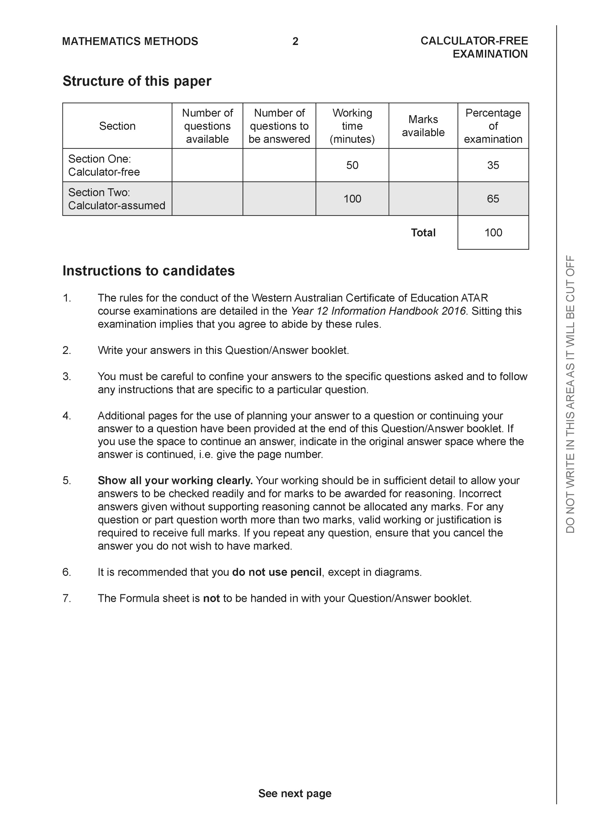

**Section One: Calculator-free (50 Marks)**

This section has **seven (7)** questions. Answer **all** questions. Write your answers in the spaces provided.

Spare pages are included at the end of this booklet. They can be used for planning your responses and/or as additional space if required to continue an answer.

● Planning: If you use the spare pages for planning, indicate this clearly at the top of the page.

● Continuing an answer: If you need to use the space to continue an answer, indicate in the original answer space where the answer is continued, i.e. give the page number. Fill in the number of the question that you are continuing to answer at the top of the page.

Working time: 50 minutes.

**Question 1 (6 marks)**

Consider the polynomial .

(a) Determine  (1 mark)

|  |
| --- |
| **Solution** |
|  |
| **Specific behaviours** |
| 🗸 states zero |

(b) Show that  is a factor of . (2 marks)

|  |
| --- |
| **Solution** |
|  |
| **Specific behaviours** |
| 🗸 subs correct value for z  🗸 shows that all 5 terms cancel to zero (simply stating is not enough) |

(c) Determine all the roots to  (3 marks)

|  |
| --- |
| **Solution** |
|  |
| **Specific behaviours** |
| 🗸 states real result as one root  🗸 uses conjugate  🗸 states all four correct roots |

**Question 2 (10 marks)**

Consider the functions  & .

1. Determine the natural domain and range of . (2 marks)

|  |
| --- |
| **Solution** |
|  |
| **Specific behaviours** |
| 🗸 states domain  🗸 states range |

1. Determine the rule for  and state its natural domain and range. (3 marks)

|  |
| --- |
| **Solution** |
|  |
| **Specific behaviours** |
| 🗸 states rule  🗸 states natural domain of f  🗸 states range |

1. Determine the rule and natural domain for . Explain why the composite exists. (3 marks)

|  |
| --- |
| **Solution** |
|  |
| **Specific behaviours** |
| 🗸 states un-simplified rules  🗸 states domain  🗸 shows relevant domain and range and rule for existence |

1. Does ? Justify. (2 marks)

|  |
| --- |
| **Solution** |
| No as natural domain is  which is different to composite. |
| **Specific behaviours** |
| 🗸 states no with a reason  🗸 correct reason |

**Question 3 (9 marks)**

Consider the function  which is drawn below for .

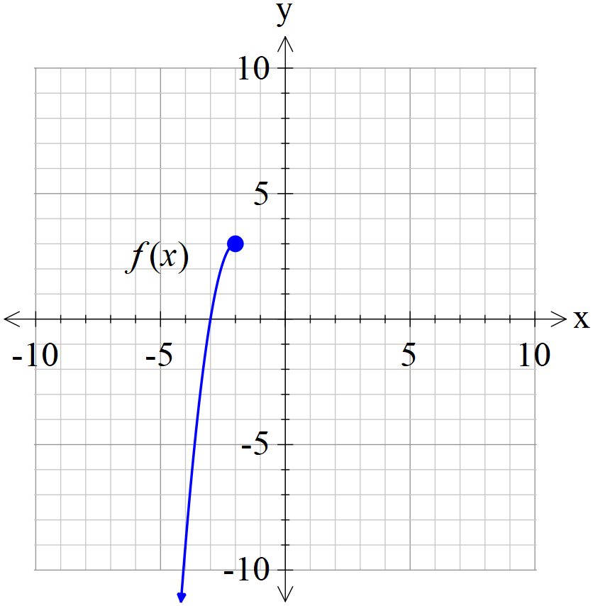

1. Sketch  on the axes above. (2 marks)

|  |
| --- |
| **Solution** |
|  |
| **Specific behaviours** |
| 🗸 appears to be reflected in line y=x  🗸 endpoints clearly plotted to scale |

1. Given that , determine the rule for  and state the domain and range. (4 marks)

|  |
| --- |
| **Solution** |
|  |
| **Specific behaviours** |
| 🗸 states domain and range of inverse  🗸 swaps x and y  🗸 solves for rule with both signs  🗸 states correct rule (may be un-simplified) |

1. Determine the exact solution(s) to if any. (3 marks)

|  |
| --- |
| **Solution** |
|  |
| **Specific behaviours** |
| 🗸 states an equation that will solve for x  🗸 solves for x using quadratic formula with working shown  🗸 discards the invalid result and states correct exact value (may be un-simplified) |

**Question 4 (3 marks)**

Consider the complex equation  for any positive integer . The  roots are designated .

Let , determine  for any positive integer . Explain.

|  |
| --- |
| **Solution** |
|  |
| **Specific behaviours** |
| 🗸 uses De Moivers  🗸 shows that there are n terms with each modulus being  🗸 states the required result |

**Question 5 (5 marks)**

|  |  |
| --- | --- |
|  | The function  is drawn to the left where  are all integers. |

|  |
| --- |
| **Solution** |
| |  |  |  |  |  | | --- | --- | --- | --- | --- | | a | b | c | p | q | | 3 | 6 | -45 | -3 | -4 | |
| **Specific behaviours** |
| 🗸 one mark for each correct value |

**Question 6 (8 marks)**

Consider the function  which is drawn below and is defined for .

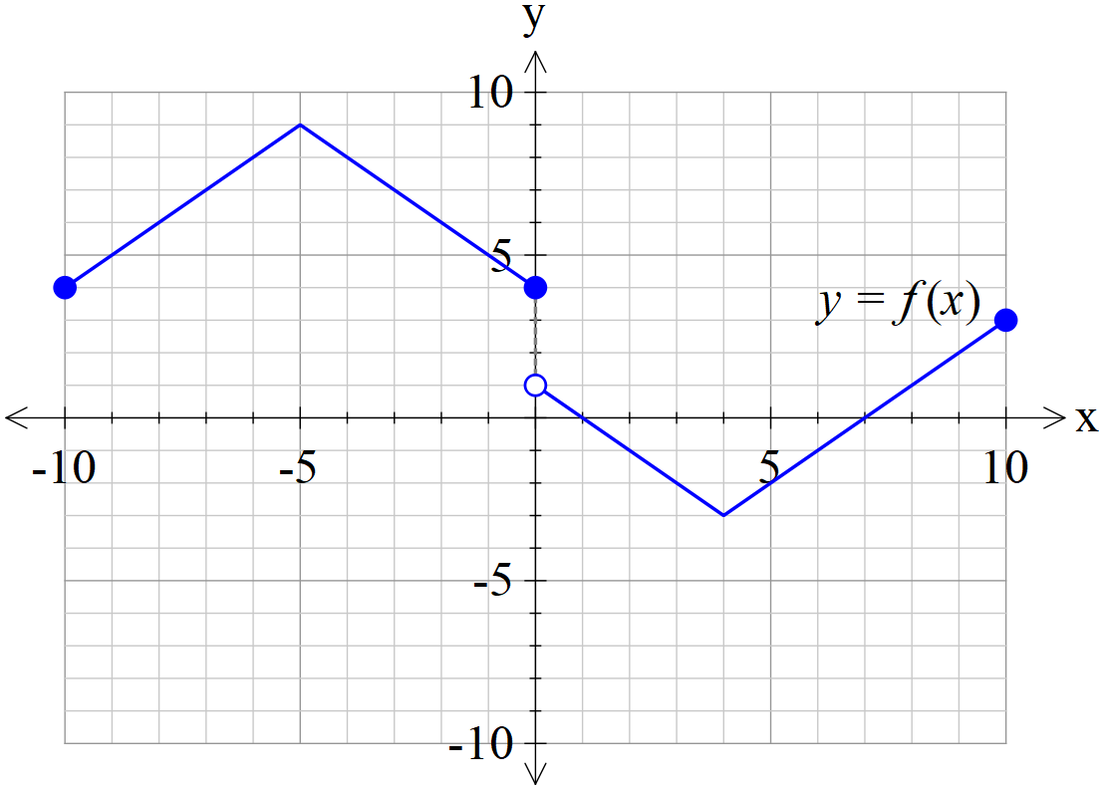

(a) Sketch  on the axes below. (2 marks)

|  |  |
| --- | --- |
|  | **1 mark reflects in y axis**  **1 mark uses left hand side** |

(b) Sketch  on the axes below. (3 marks)

|  |  |
| --- | --- |
|  | **1 plots y intercept as 5 only**  **1 mark uses right hand side**  **1 mark reflects negative ys in x axis** |

(c) Sketch  on the axes below. (3 marks)

|  |  |
| --- | --- |
|  | **1 mark for defined y intercept**  **1 mark for both vertical asymptotes dotted**  **1 mark for shape** |

**Question 7 (9 marks)**

Consider a projectile that has an initial speed, , at an angle of  with the horizontal

that moves with an acceleration of  where  is a constant.

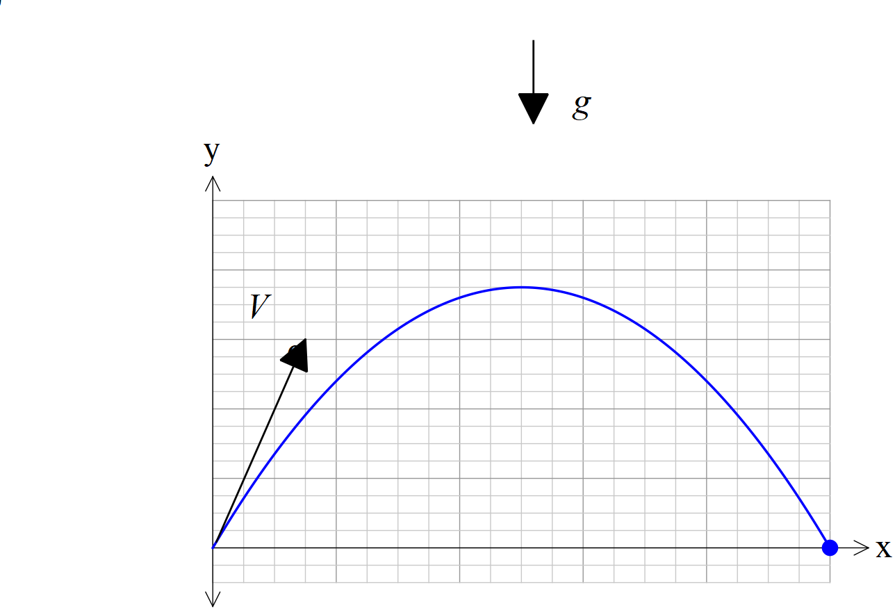

1. If the projectile begins at the origin, show that a time, , and using vector calculus that the velocity vector is given by: (2 marks)



|  |
| --- |
| **Solution** |
|  |
| **Specific behaviours** |
| 🗸 determine initial velocity  🗸 integrates and solves for vector constant |

1. In terms of  derive the cartesian equation of the projectile. (4 marks)

|  |
| --- |
| **Solution** |
|  |
| **Specific behaviours** |
| 🗸 integrates and shows vector constant  🗸 obtains expression for t using x parametric equation  🗸 subs t into y parametric equation  🗸 derives above equation |

1. Given that  show that  is a solution of the following equation.

. (3 marks)

|  |
| --- |
| **Solution** |
|  |
| **Specific behaviours** |
| 🗸 uses secx  🗸 uses identity for tan and sec  🗸 subs values for V & g |